Experiment: 8

Steering Angle Variation in MIMO Beamforming Using MATLAB

Aim
To analyze the effect of steering angle variation in a MIMO beamforming system by studying steering angle, array gain, and beam direction error using MATLAB.

Objectives
- To analyze the steering angle of a MIMO beamforming system by directing the beam towards different target directions using MATLAB.
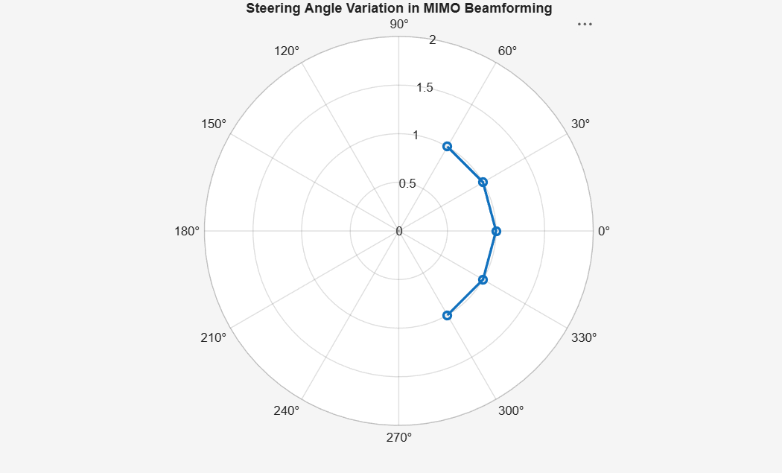
- To compare the array gain achieved for different steering angles in a MIMO beamforming system using MATLAB.
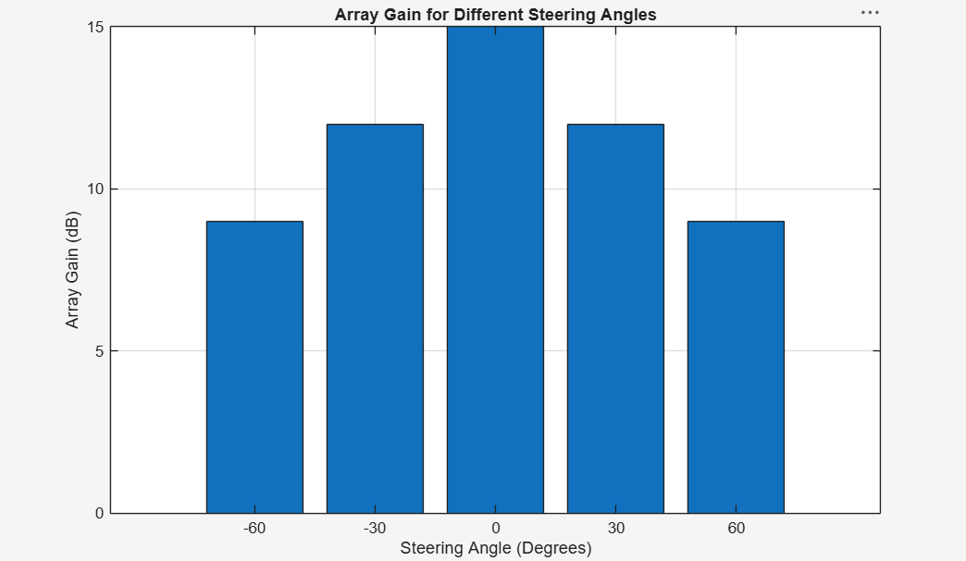
- To evaluate the beam direction error between the desired steering angle and the actualbeam direction using MATLAB.
